Project Report
SQL

1) Get total number of users

Query:-

SELECT COUNT(*) AS total_users FROM users;

Use Case:-

How many users are registered on my e-commerce platform?

Measure platform growth over time
Track marketing campaign performance (e.g., how many users joined after ads or offers)
Understand the size of the customer base



2) Get total number of users based on gender

Query:-

Select gender,count(user_id) as total_user from user_profile group by gender;

Use Case:-

This query is used to understand the gender distribution of users on the e-commerce platform, which helps the business analyze its customer demographics.
The output shows total users by gender, helping the business design targeted marketing campaigns, personalize product recommendations, and improve sales conversion.



3) Get total number of active users

Query:-

select count(user_id) as total_active_user from users where is_active = 'true';

Use Case:-

This query is used to find how many users are currently active on the e-commerce platform, which shows real engagement instead of just total sign-ups.
The output gives the total active users, helping the business measure retention, evaluate product–market fit, and focus marketing on re-engaging inactive users.



4) List all active products

Query:-

SELECT product_id, product_name, price, stock_quantity FROM product WHERE is_active = TRUE;

Use Case:-

This query is used to list all active products that are currently available for sale on the e-commerce platform.
The output shows product details with stock levels, helping the business manage inventory, avoid selling inactive items, and ensure customers only see purchasable products.

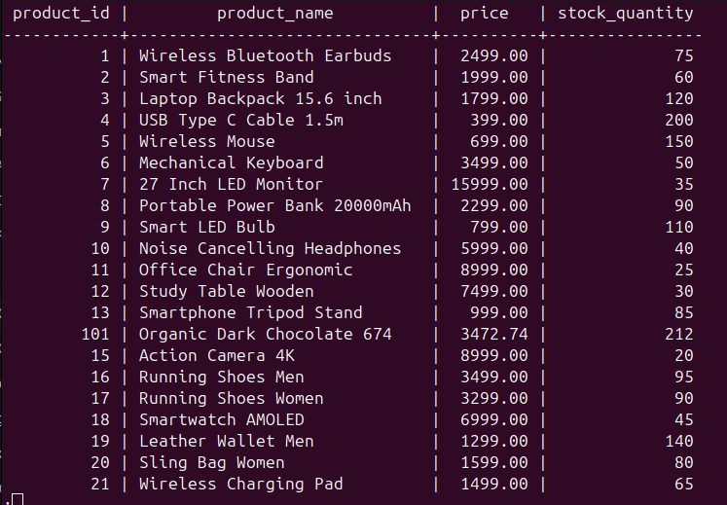

5) List products into multiple price categories

Query:-

SELECT product_id,product_name,price,
CASE
WHEN price < 300 THEN 'Ultra Budget'
WHEN price BETWEEN 300 AND 799 THEN 'Budget'
WHEN price BETWEEN 800 AND 2499 THEN 'Standard'
WHEN price BETWEEN 2500 AND 4999 THEN 'Premium'
ELSE 'Luxury'
END AS price_category
FROM product;

Use Case:-

This query is used to classify products into price segments like Budget, Premium, and Luxury, which helps the business understand its product positioning.
The output shows each product with its price category, helping the business design better pricing strategies, targeted promotions, and segment-wise sales analysis.
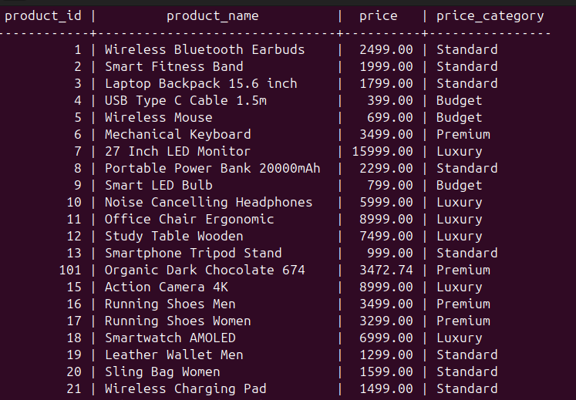

6) Count products in each price category

Query:-

SELECT
CASE
WHEN price < 300 THEN 'Ultra Budget'
WHEN price BETWEEN 300 AND 799 THEN 'Budget'
WHEN price BETWEEN 800 AND 2499 THEN 'Standard'
WHEN price BETWEEN 2500 AND 4999 THEN 'Premium'
ELSE 'Luxury'
END AS price_category,
COUNT(*) AS total_products
FROM product
GROUP BY price_category
ORDER BY total_products DESC;

Use Case:-

This query is used to see how many products fall into each price category, helping the business understand its product portfolio distribution.
The output shows total products by price segment, helping balance inventory, avoid overloading one segment, and plan better pricing and sourcing strategies.
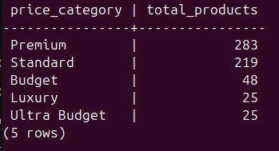

7) Get average order value

Query:-

select avg(total_amount) as total_avg_amount from orders where status ='paid';

Use Case:-

This query is used to calculate the average order value for all successfully paid orders, which shows how much customers spend per purchase on average.
The output gives a single average amount, helping the business improve pricing, design upselling or bundling offers, and increase overall revenue.
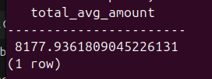

8) Get pending payments

Query:-

select order_id, user_id, total_amount, payment_method from orders where payment_status = 'pending';

Use Case :-

This query is used to identify orders with pending payments, helping the business track incomplete purchases and potential revenue loss.
The output shows pending order details, helping the business send payment reminders, fix payment issues, and recover abandoned revenue.

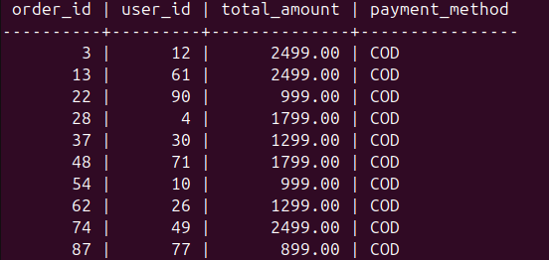
9) Get low-stock products

Query:-

select product_id, product_name, stock_quantity from product where stock_quantity < 10;

Use Case:-

This query is used to find products with very low stock levels, helping the business detect items that are close to being out of stock.
The output shows low-inventory products, helping the business restock on time, prevent lost sales, and maintain smooth order fulfillment.
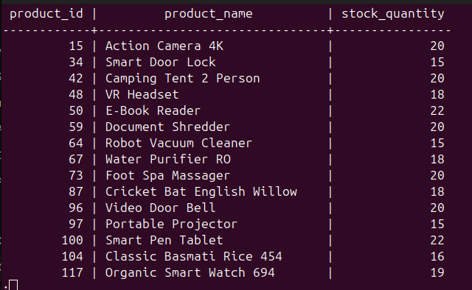

10) Count how many orders came from each payment method (UPI, COD, etc.)

Query:-

select payment_method, count(*) as total_orders from orders group by payment_method order by total_orders desc;

Use Case:-

This query is used to analyze which payment methods customers prefer on the e-commerce platform.
The output shows total orders by payment method, helping the business optimize payment options, negotiate better gateway fees, and improve checkout conversion rates.

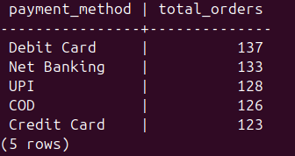

11) Get total revenue generated

Query:-

select sum(total_amount) as total_revenue from orders where status = 'paid';

Use Case:-

This query is used to calculate the total revenue generated from all successfully paid orders on the e-commerce platform.
The output gives a single revenue number, helping the business track overall performance, measure growth, and plan future sales and marketing strategies.

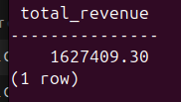

12) Get users who never placed any order
Query:-

select u.user_id, u.username from users u left join orders o on u.user_id = o.user_id
where o.order_id is null;

Use Case:-

This query is used to find registered users who have never placed any order, helping the business identify inactive or non-converting customers.

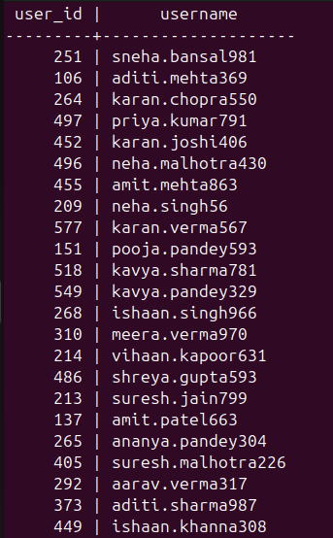

13) Get most recent orders

Query:-

select order_id, user_id, total_amount, created_at from orders order by created_at desc limit 10;

Use Case:-

This query is used to fetch the 10 most recent orders to monitor latest sales activity on the e-commerce platform.
The output shows recent order details.

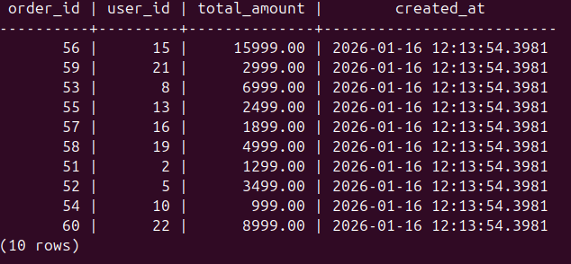

14) Get users who added items to cart but never ordered

Query:-

select distinct u.user_id, u.username from users u join cart c on u.user_id = c.user_id left join orders o on u.user_id = o.user_id where o.order_id is null;

Use Case:-

This query is used to find users who added items to their cart but never completed a purchase, helping the business identify cart abandonment behavior.
The output shows such users, helping the business send reminder emails, offer discounts, and recover lost sales.
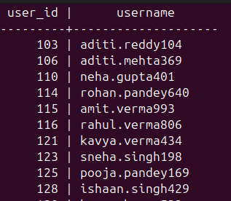

15) Products never sold

Query:-

select p.product_id, p.product_name from product p left join order_item oi on p.product_id = oi.product_id where oi.order_item_id is null;

Use Case:-

This query is used to find products that have never been sold, helping the business identify dead or underperforming inventory.
The output shows unsold products, helping the business run discounts, improve product listings, or remove low-demand items to optimize inventory and revenue.

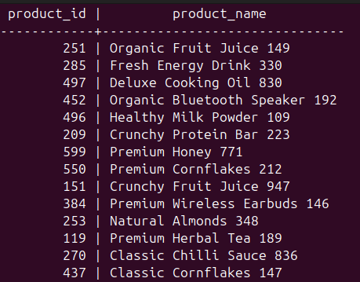

16) Orders by city

Query:-

select a.city, count(o.order_id) as total_orders from orders o join address a on o.address_id =
a.address_id group by a.city order by total_orders desc;

Use Case:-

This query is used to find which cities generate the highest number of orders, helping the business understand geographic demand.
The output shows total orders by city, helping the business focus marketing, improve delivery logistics, and expand operations in high-performing locations.

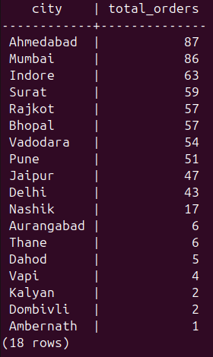

17) Revenue by city

Query:-

select a.city, sum(o.total_amount) as revenue from orders o join address a on o.address_id = a.address_id where o.status = 'paid' group by a.city order by revenue desc;

Use Case:-

This query is used to calculate total revenue generated from each city to understand which locations are most profitable for the e-commerce business.
The output shows revenue by city, helping the business prioritize high-revenue regions, optimize delivery networks, and run location-based marketing campaigns.

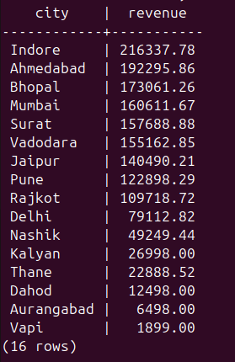

18) Average product price sold

Query:-

select avg(order_item.price_at_purchase) as avg_selling_price from order_item;

Use Case:-

This query is used to calculate total revenue generated from each city to understand which locations are most profitable for the e-commerce business.
The output shows revenue by city, helping the business prioritize high-revenue regions, optimize delivery networks, and run location-based marketing campaigns.

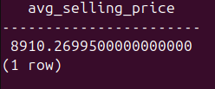

19) Total stock available

Query:-

select sum(stock_quantity) as total_stock from product;

Use Case:-

This query is used to calculate the total inventory available across all products on the e-commerce platform.
The output shows overall stock levels, helping the business plan restocking, avoid overstocking, and ensure product availability to meet customer demand.



20) Payment status distribution

Query:-

select payment_status, count(*) as total_orders from orders group by payment_status;

Use Case:-

This query is used to calculate the total inventory available across all products on the e-commerce platform.
The output shows overall stock levels, helping the business plan restocking, avoid overstocking, and ensure product availability to meet customer demand.

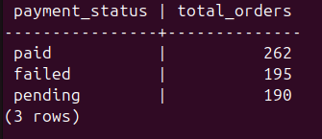

21) Total number of items currently in all carts

Query:-

select sum(quantity) as total_cart_items from cart_item;

Use Case:-

This query is used to find the total number of items currently added to all user carts, which reflects overall shopping interest and intent to buy.
The output shows total cart items, helping the business forecast demand, detect high-interest products, and plan inventory and promotions accordingly.



NoSQL

1) Most Completed Audiobooks

Query:-

db.purchases.aggregate([
{ $match: { payment_status: "paid" } },
{ $group: { _id: null, total_revenue: { $sum: "$price_paid" } } }
])

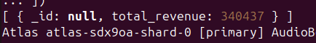
Use Case:-
This query is used to calculate the total revenue from all successfully paid purchases, giving a clear picture of actual earnings for the AudioBook business.

2) Total Number of Paying Customers
Query:-
db.purchase.distinct("user_id").length
Use Case:-
This query is used to find how many unique users have purchased audiobooks, which shows the size of the paying customer base on the platform.

3) Best-Selling Audiobooks (by number of purchases)

Query:-
db.purchases.aggregate([
{ $group: { _id: "$audiobook_id", total_sales: { $sum: 1 } } },
{ $sort: { total_sales: -1 } }
])

Use Case:-
This query is used to find which audiobooks are selling the most by counting total purchases per audiobook.

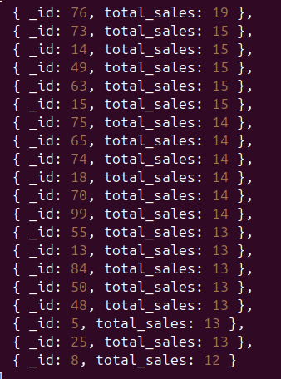

4) Users Who Bought More Than One Audiobook
Query:-
db.purchases.aggregate([
{ $group: { _id: "$user_id", total_purchases: { $sum: 1 } } },
{ $match: { total_purchases: { $gt: 1 } } }
])

Use Case:-
This query is used to identify users who have purchased more than one audiobook, which highlights repeat and loyal customers on the platform.
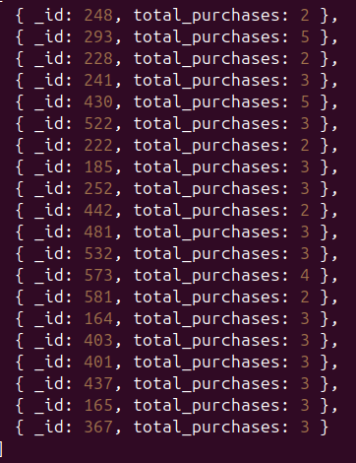

5) Users Who Completed Their Audiobook
Query:-
db.listening_progress.find({ completed: true })

Use Case:-
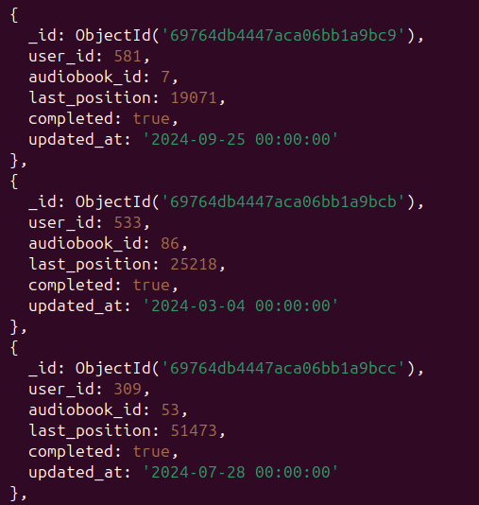
This query is used to find users who have fully completed audiobooks, which shows real engagement and content quality.

6) Most Popular Tags
Query:-
db.audio_book.aggregate([
{ $unwind: "$Tags" },
{ $group: { _id: "$Tags", count: { $sum: 1 } } },
{ $sort: { count: -1 } }
])

Use Case:-
This query is used to find the most common audiobook tags to understand which genres or themes are most popular on the platform.

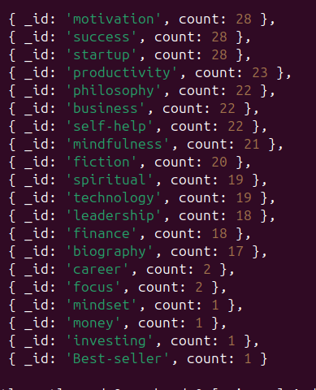

7) Audiobooks with Zero Sales
Query:-
db.audio_book.aggregate([
{
$lookup: {
from: "purchase",
localField: "audiobook_id",
foreignField: "audiobook_id",
as: "sales"
}
},
{ $match: { sales: { $size: 0 } } }
])

Use Case:-
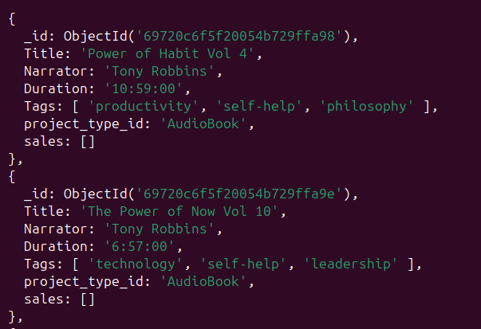
This query is used to find audiobooks that have never been purchased, helping the business identify low-performing or invisible content.

8) Total Number of Audiobooks , Users & Total Number of Purchases

Query:-
db.audio_book.countDocuments()
db.users.countDocuments()
db.purchases.countDocuments()

Use Case:-
These queries are used to get total counts of audiobooks, users, and purchases, giving a quick overview of platform size and activity.
The output shows basic growth and usage metrics, helping the business track content expansion, user adoption, and overall sales performance.

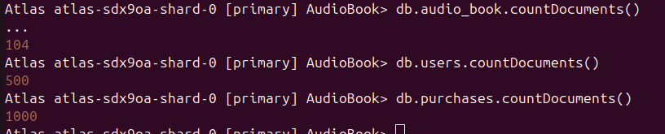

9) Top 5 Highest Paying Users
Query:-
db.purchases.aggregate([
{ $group: { _id: "$user_id", total_spent: { $sum: "$price_paid" } } },
{ $sort: { total_spent: -1 } },
{ $limit: 5 }
])
Use Case:-
This query is used to find the top 5 users who have spent the most money on audiobooks, identifying the highest-value customers on the platform.
The output ranks users by total spending, helping the business reward loyal users, offer premium plans, and increase revenue through personalized offers.



10) Users with Only One Purchase
Query:-
db.purchases.aggregate([
{ $group: { _id: "$user_id", orders: { $sum: 1 } } },
{ $match: { orders: 1 } }
])
Use Case:-
This query is used to find users who have purchased only one audiobook, helping the business identify low-retention or one-time buyers.
The output shows such users, helping the business run follow-up offers, improve recommendations, and increase repeat purchases.

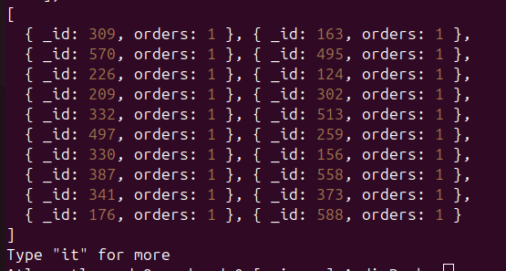

11) Most Recent Purchases

Query:-
db.purchases.find().sort({ purchased_at: -1 }).limit(10)

Use Case:-
This query is used to fetch the 10 most recent audiobook purchases to monitor latest sales activity on the platform.
The output shows recent purchase records, helping the business track real-time performance and quickly respond to trends or issues.
